DVM WorkSpaces – Marketing
7/18/2014

- This product should be able to have some patents for it.
- I should probably look for attracting some capital for it, perhaps crowd sourced.
- I should also think about this as probably the first step in a larger initiative to re-invigorate and replace the Windows desktop and such with next generation software.
- Possibilities are significant….

“Smart Software for Smart People”

“Regular People Just Have Directories…Smart People Have WorkSpaces!”

When is a directory not just a directory?

When it goes from this:

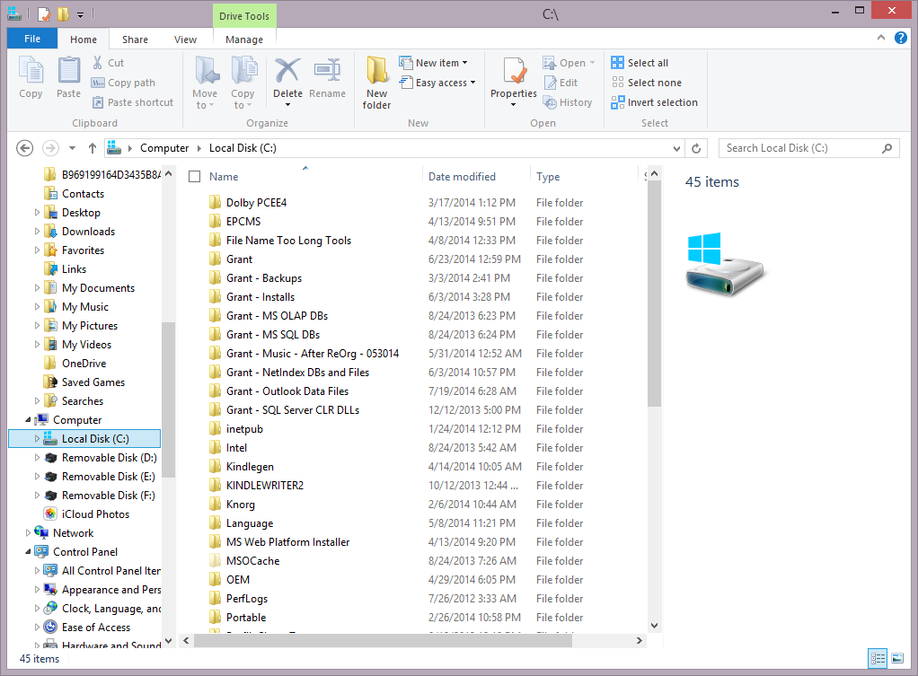

To This! A DVM WorkSpace!!!

Easily Add Custom Images to Represent Your Files and Folders!
See Where You Were…And Restart From There Instantly!

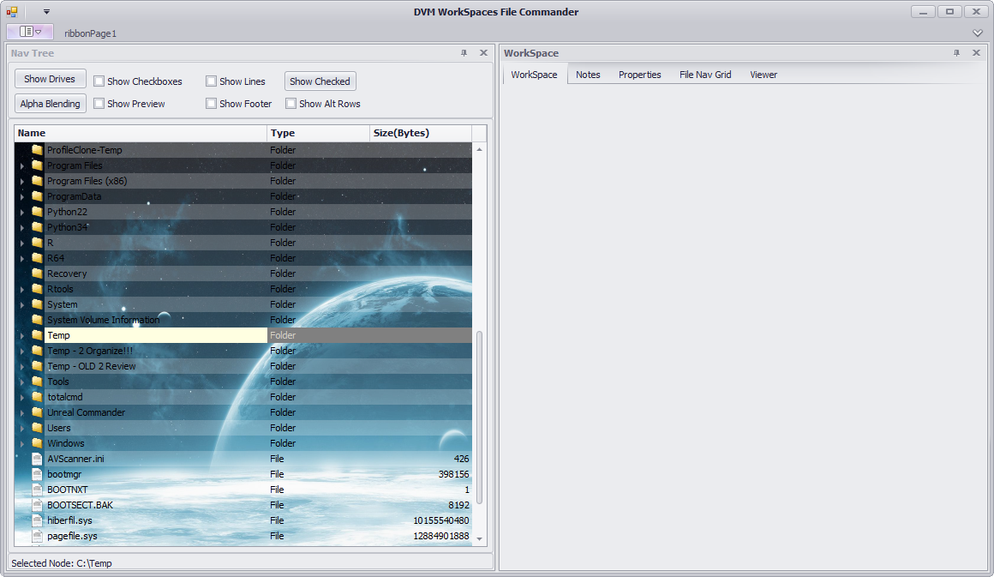





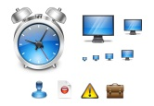
Draw on it!

Don’t forget to finish that report on the XYZ project!




Tasks:
- Do this…
- And this…
- And this…

Add Notes to Files, Folders, and WorkSpaces!
Advanced File Manager Built In!
Create Virtual Folder and File Groups!

Custom Task Lists and Other Lists!

…AND Now EACH AND EVERY ONE of your previously boring and limited directories on your PC can now instantly become a
DVM WorkSpace!!!

Allowing you a convenience and a productivity that you only dreamed of before!!!
- Show main features on the screen here!!!!
  - With arrows!
  - Show all the main features and selling points!!!

